Lab 3 Problems

Using OpenGL, draw the following figures. The dimensions of the various components in the figures can be considered as you wish, but the overall shape should be the same as the figures given here

1. Draw House

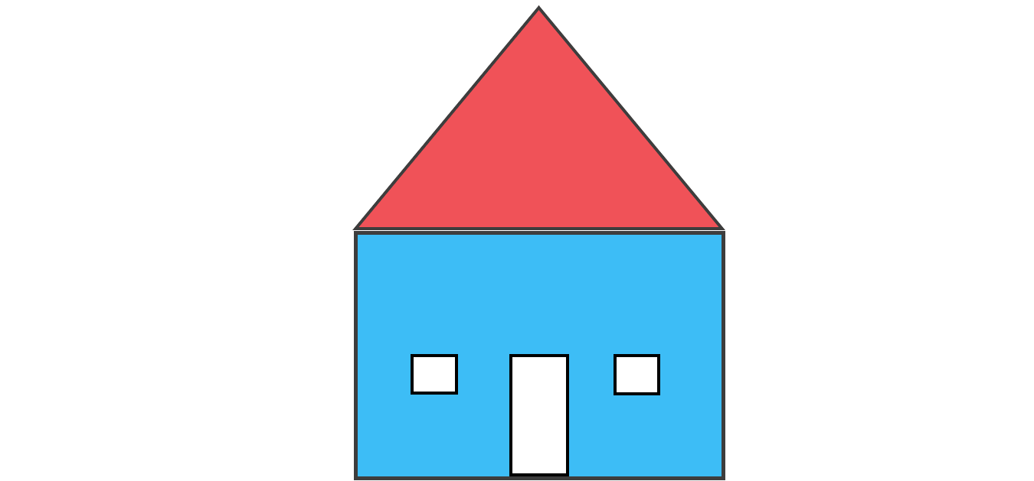

1. Draw Car

